Welcome to the Spring 2021newsletter!

What will be doing this term?
Our learning intentions this term include; getting ready for school, learning quantity and quality, recognising our names and learning the names of our friends at circle time and focused reading groups for our pre-school children. We will be welcoming new friends and helping them to feel safe and comfortable with us at nursery!
Children will be doing their own individual baking to take home, with recipes and methods you can also try at home. Children will also be making their own individual play-doh which they will be bringing home.
Spring term progress summaries
Parents will receive a copy of their child’s spring term report, where there is a space for you to write a comment and sign. If you would like to ask any questions about your child’s development in particular or have any concerns you would like to discuss, please speak to your child’s key person.
New displays
We are currently revamping some of our displays for the new term and would like children to bring in a photo of their family for our family board. Please provide us with a photograph of your child and their family and pets. Thank you.
Polite reminder

Please ensure you are wearing a face covering when you are dropping off and collecting your child and leave space of 2 metres from the door.
Thank you.

Dates for your diary

Tuesday 5th January 2021 – Thursday 1st April 2021
INSET DAY
Monday 4th January 2021 (Nursery Closed for Children)

Half Term Holiday Monday 15th – Friday 19th February 2021

Summer Term
Monday 19th April 2021 – Thursday 15th July 2021
INSET DAY
Friday 16th July 2021 (Nursery Closed for Children)

Half Term Holiday Monday 31st May 2021 – Friday 4th June 2021

How can we help you?
We understand the current times can be challenging for all and so we want to offer any support, guidance and advice wherever we can. Attached below, are some useful website links for your information, if you feel you need it. Also, please feel free to speak to your child’s nursery workers or anyone you feel comfortable with if you require any particular advice or support or just need a chat. We have the necessary tools to assist and direct you, so please don’t hold back.
- Local children centre’s can offer workshops and support for parents and children (please speak to your child’s nursery)
- www.nhs.uk/oneyou/every-mind-matters - looking after your mental health
- jo@samaritans.org OR call 116 123 to talk to someone at Samaritans
- www.gov.uk/find-coronavirus-support - Government website for support during the Coronavirus pandemic
- www.gov.uk/guidance/domestic-abuse-how-to-get-help - Government website for domestic abuse support or
- Call Refuge’s National Domestic Abuse Helpline for free and confidential advice, 24 hours a day on 0808 2000 247.

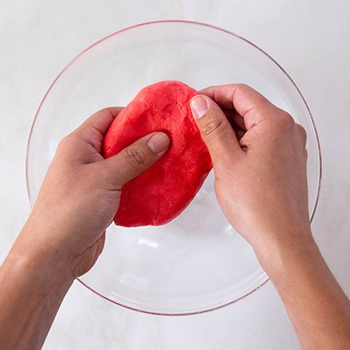
Marshmallow Play Dough

Ingredients

6 large marshmallows

2 teaspoons coconut oil

Food colouring

4 tablespoons corn flour

Instructions
- Warm the marshmallows and coconut oil in your microwave for 30 seconds, then stir in a few drops of food colouring. Use as many drops as you need to create the colour you want. After you’ve got the right colour, stir in the corn flour. When the dough is cool enough to handle, start kneading it.
- If the dough still feels too sticky, add a little more corn flour.
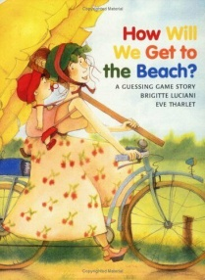
Books provide a great opportunity for learning and engagement. Here are some books you might want to try:
‘Pants’ – an eye catching book about pattern
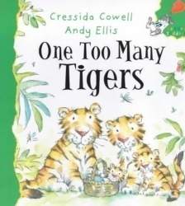
‘How will we get to the beach?’ – provides opportunity for problem solving
‘One too many tigers’ – a counting book

There’s more to Maths than counting!
10 things to practice at home to develop maths skills:
1. Let your child help you to sort clean clothes – putting pairs of socks together, identifying baby’s small T-shirt and daddy’s big one.
2. Asking whether he or she would like one or two spoonfuls of dhal or one or two spoons of ice cream.
3. Babies can be engrossed for long periods by a small collection of everyday objects. For example, as they play, with a wooden spoon, a potato masher, a wooden egg cup, two conkers and a scarf they are learning about many mathematical ideas such as shape, size, and weight.
4. Filling small bags and boxes with objects.
5. Reading about and choosing TV programmes and using the remote control to select the appropriate channel.
6. Organising shoes according to size.
7. When out shopping, asking children to collect some of the items – “I need five onions; can you pick the biggest one. Is there a smaller one?”
8. Looking for shapes and patterns when walking in the street or park.
9. Making and playing skittles - using plastic bottles with gravel or sand in the bottom for weight. Talk about how many they knock down or guessing how many!
10. Encourage your child to tidy toys into boxes, baskets, cupboards etc.

